Room C
CQ1 Incarcerated Femoral Hernia
Stem: 56 yo female presents to the emergency room with 18 hour history of nausea, vomiting, abdominal distension. Notes that she is otherwise healthy and was working in her garden yesterday and began to have pain in her right thigh radiating down the front of her leg. Thought it was a muscle strain so laid down for a couple hours but was awakened overnight by a feeling of nausea and abdominal pain and came to the emergency room.
PMH: HTN
PSH: None
Physical exam
- Afebrile
- Abdomen moderately distended, diffusely tender without rebound or guarding, no masses, + BS
- Rectal: Normal tone, no mass, GUAIC -
- Extremities: Firm tender mass with erythema at right superomedial thigh
Labs: WBC 11.4, Hgb 12.6, electrolytes K 3.3, otherwise normal
Imaging:
- CXR normal
- KUB: c/w dilated small bowel with multiple air fluid levels
What is your Differential Dx?:
- SBO due to
  - Hernia
  - Malignancy
  - IBD
  - Gallstone Ileus
  - Intussusception
  - Adhesions (less likely since no prior surgery)

What Would you like to do?
- Obtain CT
CT scan notable for findings c/w SBO with transition point posterior at right inguinal ligament with loops of bowel noted on superomedial right thigh

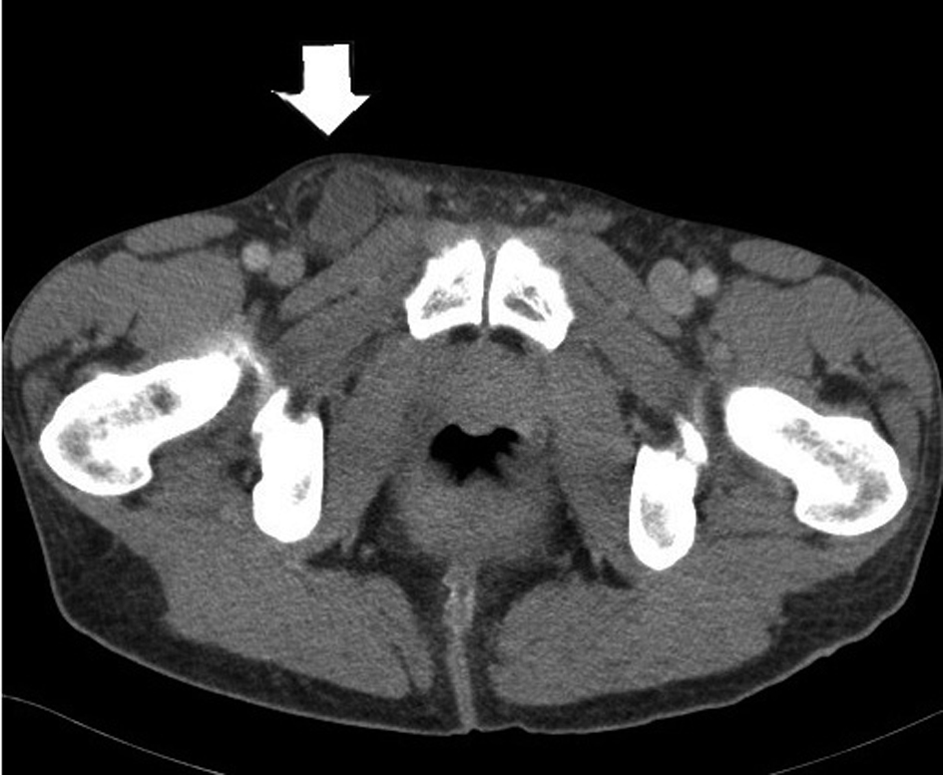

What is your diagnosis? Femoral hernia with Incarceration
What is your plan?
- Laparoscopic TAPP or TEPP
  - If attempt laparoscopically... ultimately unable to reduce
  - should be able to describe incising the fascia anterior to the hernia mass in order to try to reduce whether lap or open approach (DeMaria)

Open repair
  - Must describe opening inguinal ligament and then inguinal floor to access femoral hernia / examine hernia content then reduce

Open Lichenstein
- Oblique skin incision two fingerbreadths superior to inguinal ligament, carried through subcutaneous tissue
- External oblique fascia is identified and incised along direction of fibers
- Isolate cord structures from hernia sac
- Open hernia sac (ensuring caution for sliding hernia) or reduce contents back intraabdominally only after contents are examined.
- Incise inguinal ligament anteriorly if unable to mobilize hernia content due to incarceration.
- Polypropylene mesh secured to pubic tubercle medially, inguinal ligament inferiorly, rectus sheath/internal oblique superiorly

Should you use mesh if contents of hernia were ischemic? No … Resident should know to describe tissue repair.
- Reapproximate external oblique

  - Hernia repair plan if bowel ischemic? Tissue repair – McVay
    - A RLQ incision is made and the external oblique aponeurosis is opened through the external ring. Care should be taken to preserve the ilioinguinal nerve. Cooper's ligament is exposed.
    - A relaxing incision should be made to reduce tension from this tissue repair. The relaxing incision should extend from the just above the pubis superiorly in the plane of fusion of the external oblique aponeurosis and the anterior rectus sheath, exposing rectus muscle.
    - The hernia sac is dissected free, excised and then closed.
    - after decision is made about bowel resection- if possible the bowel should be exteriorized via the incision and run to make sure no ischemic bowel slipped back into abdomen.
    - Preperitoneal tissues are closed with a running absorbable suture.
    - Starting medially, Interrupted sutures are then placed between the transversus abdominis and Cooper's ligament, then transition suturing to the femoral sheath, avoiding the femoral vein which lies beneath the opened floor just anterior to Cooper’s ligament.
    - The repair is then continued laterally with sutures between transversus abdominis and the shelving edge of the inguinal ligament.
    - The spermatic cord exits through the newly created internal ring.
    - The external oblique is closed over the top of the spermatic cord.

CQ2 Leak S/P Bariatric Surgery
Stem: A 45-year-old male presents to the emergency room with left chest and back pain, nausea, shortness of breath, and subjective fever. He underwent an uncomplicated laparoscopic bariatric procedure 10 days earlier in another hospital, and his current body mass index (BMI) is 58 m/kg2.
PE: Diaphoretic. Vitals: Temp 38.5°C, HR 114, Bl.Pr 114/75, RR 20, O2 94%. Abdomen is nontender and incision sites are dry and intact without signs of erythema or drainage.
PMH/PSH: GERD, HTN, Hyperlipidemia, COPD, appendectomy.
Social History: Prior smoker, drinks EtOH weekly.
Meds: Metformin.
Family history: Unremarkable.

Labs: CBC (WBC 18000, H&H 11/32) BMP (Na 144, k 4.5, Cl 98, Cr 2.9) Troponin Normal. Lactate 3.9.

What is your Differential Diagnosis?
- GI leak.
- Postoperative bleeding.
- Missed bowel injury.
- Missed pancreatic injury.
- PE. (Hence CT chest below)
- MI
What would you like to do now?
- Resuscitation: Two wide bore IV cannulas, IVF , Broad spectrum Abx.
- Obtain operative report.
- CT Chest , abdomen and pelvis: What Contrast? IV &Oral. Oral should be specifically mentioned.
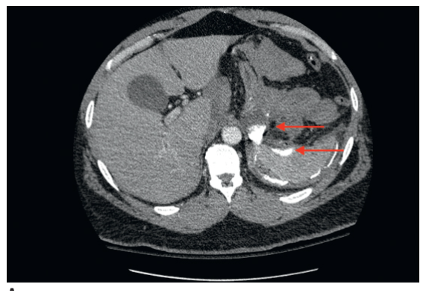

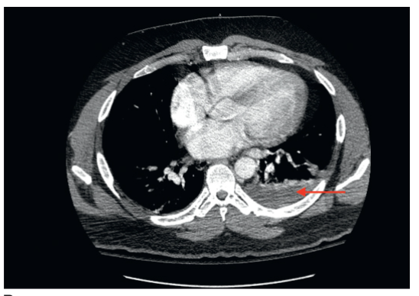
Contrast extravasation and extraluminal air along with a complex fluid collection located in the left subdiaphragmatic space.
You obtain and review the operative report, patient procedure was sleeve gastrectomy, what is your diagnosis in this case and how would you proceed.
- Gastric staple line leak, presenting with sepsis.
- Laparoscopic exploration. (Preferred) for irrigation and Drainage.
Endoscopic stent is not the best answer due to the presentation with sepsis requiring drainage/washout of infected fluid however the answer could include placement of a stent at the time of surgery versus suture repair of a leak depending on leak location (ie useful if proximal stomach) (DeMaria)
Describe how you would perform the procedure?
- Veress needle at Palmer’s point.
- Port is placed in the left upper quadrant. Angled laparoscope (5 or 10 mm)
- The patient is placed in the steep reverse Trendelenburg position, and additional ports are placed.
- Left lateral segment of the liver is retracted to facilitate exploration.
- Careful exploration of the left upper quadrant with blunt atraumatic graspers.
- Intraoperative endoscopy can facilitate identification of the location of the leak using air insufflation technique.
- Identify and drain any abscess cavity.
- Irrigate copiously with warm saline.
- Place one or more drains into the abscess cavity in anticipation of as a continued leak post op is very likely in the setting of sleeve leak. .

If appropriate drainage/washout cannot be accomplished via laparoscopy then open conversion is appropriate in order to accomplish.
(Examiner please note, Identification of the exact location of the leak is not absolutely necessary, the primary focus of this exploration is drainage. In addition, primary repair is often not feasible, and narrowing by overzealous attempts at repair of a sleeve or gastric bypass pouch leak can result in a stricture. )
- You identify the leak site, now what? Omental patch , placing seromuscular sutures through healthy gastric tissue and omentum.

- Endoscopic stent placement can be considered if leak location is identifiable and immediately available expertise to perform this procedure including fluoro, stents,etc.
Might need to be delayed until appropriate personnel available and further imaging determine precise leak location. Mi

- Consider placing feeding jejunostomy. Describe?
  - Place four sutures (2-0 braided absorbable sutures are used typically) in a diamond formation along the antimesenteric portion of the small bowel.
  - Enterotomy is created in the middle of the four sutures.
  - 12- to 14-Fr silastic feeding tube is advanced into the bowel directing it distally along the jejunum.
  - The four sutures are anchored to the abdominal wall
  - The drain is then sutured to the skin with a 3-0 nylon suture.
What are some protentional complications that can occur during or following this takeback surgery?
- Splenic injury
- Pancreatic injury.
- Splenic flexure colon injury.
- Gastrocolic fistulas
- Chronic fistula from leak site.

CQ3 BREAST LCIS
Stem: You are seeing a 58y postmenopausal female after a routine mammogram showed calcifications the right breast, they weren’t appreciated on the mammogram the year prior. She denies any changes in her breasts or axillae. Family history is negative for breast or gynecologic malignancies. Her physical exam is unremarkable.

What is your Differential Dx?
- DCIS
- LCIS
- Invasive breast cancer
- Atypical ductal or lobular hyperplasia
- Fibrocystic changes
- Fat necrosis

Additional Workup or Studies?

- Diagnostic mammogram reveals fine linear branching calcifications located near the chest wall in the upper, outer quadrant of the right breast; the calcifications appear focal and do not appear to be multicentric
- Stereotactic core needle biopsy

core needle biopsy returns as LCIS (ER/PR +, HER2/neu negative). You proceed to OR for excisional biopsy, Pathology returns LCIS, positive inferior margin

What would you like to do now?

- Observation:
- H&P q6 months x5y
- Mammogram in 6 months then annually
- Anastrozole or raloxifene

- bilateral prophylactic mastectomy +/- reconstruction, however usually reserved/recommended for patients with strong family history and/or high genetic risk.

(To examiner: Examinee should recognize that LCIS is a marker of increased risk but not an actual precursor lesion therefore -no tumor on ink- does not apply)

Describe a mastectomy
- Orient elliptical incision to include nipple–areolar complex, previous biopsy site, and overlying skin.
- Use electrocautery and gentle traction to develop the connective tissue plane superficial to the breast parenchyma in creation of the skin flaps.
- Dissection borders are superiorly to the clavicle, medially to the lateral border of the sternum, inferiorly to the anterior rectus sheath, and laterally to the anterior border of the latissimus dorsi muscle.
- Remove the breast from the pectoralis muscle, including the pectoralis fascia.
- Perform sentinel lymph node biopsy utilizing the same incision.
- Ensure hemostasis, place drain, and close.

